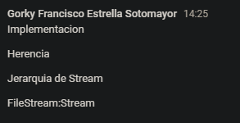



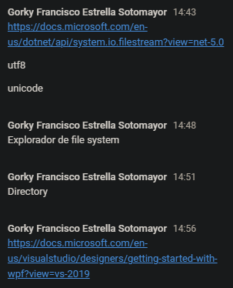

<https://meet.google.com/linkredirect?authuser=1&dest=https%3A%2F%2Fdocs.microsoft.com%2Fen-us%2Fdotnet%2Fapi%2Fsystem.io.filestream%3Fview%3Dnet-5.0>

https://meet.google.com/linkredirect?authuser=1&dest=https%3A%2F%2Fdocs.microsoft.com%2Fen-us%2Fvisualstudio%2Fdesigners%2Fgetting-started-with-wpf%3Fview%3Dvs-2019